0nline course registration

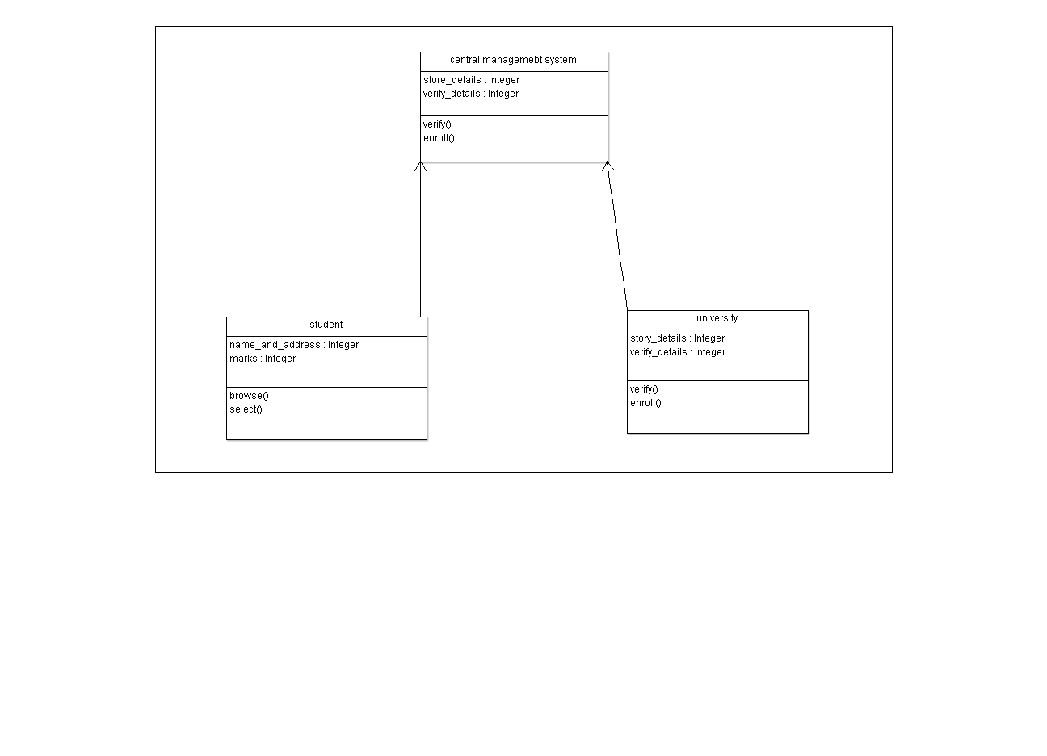

Code:

#include "central managemebt system.h"

void central managemebt system::verify()

// don't delete the following line as it's needed to preserve source code of this autogenerated element

// section -84-18-50-11-f3cf9e7:1859fe88202:-8000:0000000000000ABE begin

{

}

// section -84-18-50-11-f3cf9e7:1859fe88202:-8000:0000000000000ABE end

// don't delete the previous line as it's needed to preserve source code of this autogenerated element

void central managemebt system::enroll()

// don't delete the following line as it's needed to preserve source code of this autogenerated element

// section -84-18-50-11-f3cf9e7:1859fe88202:-8000:0000000000000AC0 begin

{

}

// section -84-18-50-11-f3cf9e7:1859fe88202:-8000:0000000000000AC0 end

// don't delete the previous line as it's needed to preserve source code of this autogenerated element

#include "student.h"

void student::browse()

// don't delete the following line as it's needed to preserve source code of this autogenerated element

// section -84-18-50-11-f3cf9e7:1859fe88202:-8000:0000000000000AC8 begin

{

}

// section -84-18-50-11-f3cf9e7:1859fe88202:-8000:0000000000000AC8 end

// don't delete the previous line as it's needed to preserve source code of this autogenerated element

void student::select()

// don't delete the following line as it's needed to preserve source code of this autogenerated element

// section -84-18-50-11-f3cf9e7:1859fe88202:-8000:0000000000000ACA begin

{

}

// section -84-18-50-11-f3cf9e7:1859fe88202:-8000:0000000000000ACA end

// don't delete the previous line as it's needed to preserve source code of this autogenerated element

#include "university.h"

void university::verify()

// don't delete the following line as it's needed to preserve source code of this autogenerated element

// section -84-18-50-11-f3cf9e7:1859fe88202:-8000:0000000000000AD2 begin

{

}

// section -84-18-50-11-f3cf9e7:1859fe88202:-8000:0000000000000AD2 end

// don't delete the previous line as it's needed to preserve source code of this autogenerated element

void university::enroll()

// don't delete the following line as it's needed to preserve source code of this autogenerated element

// section -84-18-50-11-f3cf9e7:1859fe88202:-8000:0000000000000AD4 begin

{

}

// section -84-18-50-11-f3cf9e7:1859fe88202:-8000:0000000000000AD4 end

// don't delete the previous line as it's needed to preserve source code of this autogenerated element